Naviance Log-in Instructions Using Clever
- Navigate to your school’s Naviance Student page:
Park Hill: https://student.naviance.com/parkhhs
- Click the Login with Clever button (do NOT use the Email or Username and Password fields on this page)
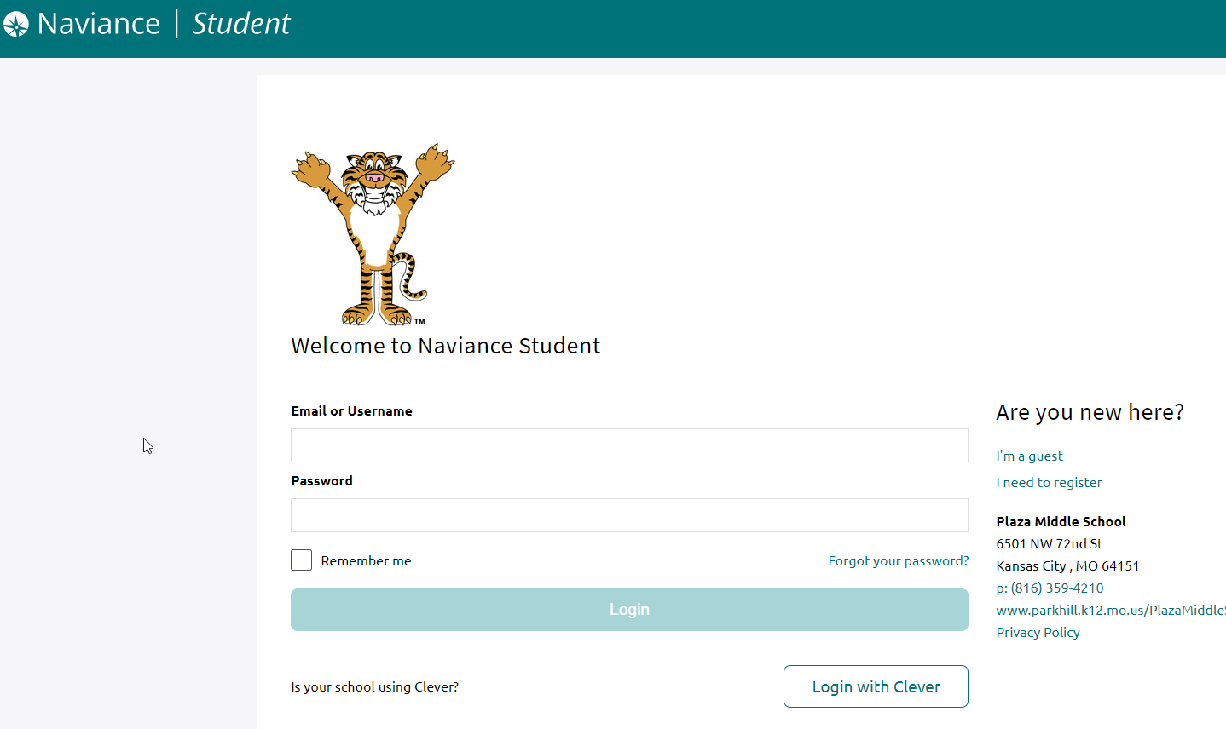
- Search for your school’s name

- Confirm that Park Hill School District appears as your district.
- Click the Log in with Active Directory button.
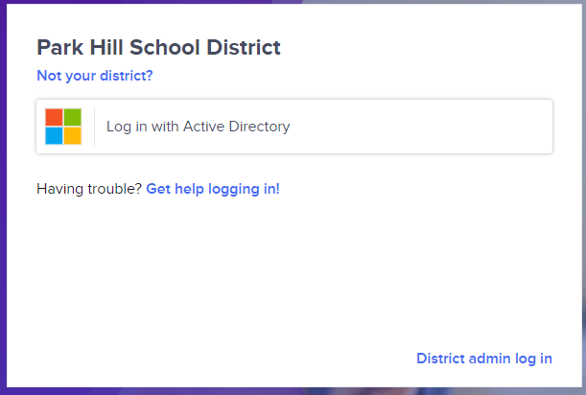
- Use your district log-in credentials (like you would to access to log-in through the Application Portal.
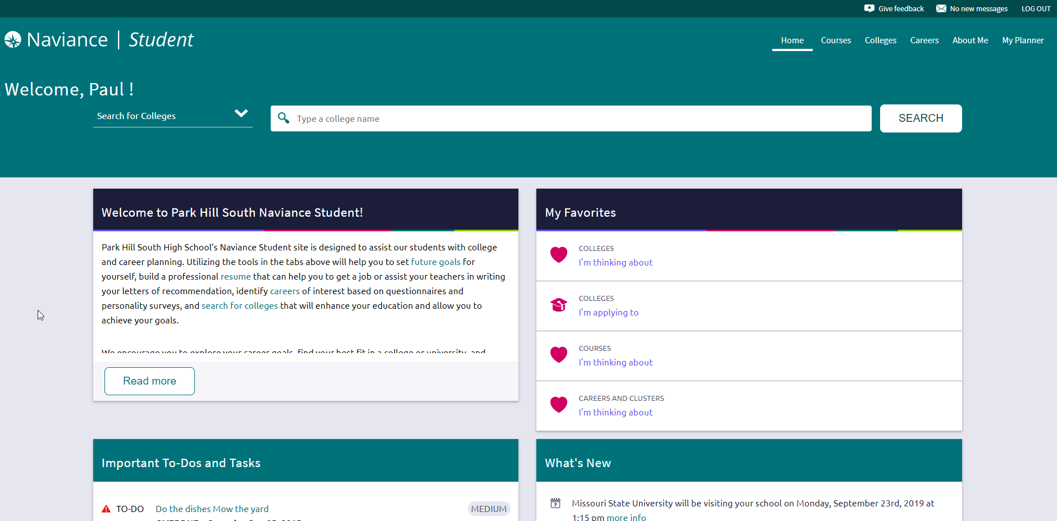
You’re logged in and ready to use Naviance Student!

